**STRUCTURAL ANALYSIS AND DESIGN OF**

**EARTHQUAKE RESISTANT BUILDING**

**STRUCTURAL REPORT**

**Owner: Mrs. Arjun Rai**

**Submitted to:**

Shankharapur Municipality, Kathmandu

**Prepared By:**

Er. Bishal Khagi

June 2025

**Table of Contents**

1 INTRODUCTION 3

2 DESIGNPHILOSOPHY 3

3 DESIGNCODESANDSTANDARDS 3

4 GENERALDESIGNCRITERIA 5

4.1 MATERIALS 5

4.2 SOIL BEARINGCAPACITY 5

4.3 METHODOLOGY 5

5 DESIGNLOAD 6

5.1 DEADLOAD 6

5.2 IMPOSEDLOAD 7

5.3 EARTHQUAKELOAD 8

6 LOADCOMBINATION 11

7 STRUCTURAL ANALYSIS USINGETABS 11

8 DESIGN METHODS OF STRUCTURALELEMENTS 12

9 LIMITSTATEMETHOD 12

11 DETAILING OF THE STRUCTURALELEMENTS: 14

12 DESIGN 33

12.1 COLUMNDESIGN 33

12.2 BEAMDESIGN 35

12.3 SLABDESIGN 37

12.4 FOUNDATIONDESIGN 40

13 ACCEPTABILITY CRITERIA 42

13.1 STORYDRIFT 42

13.2 STORYDISPLACEMENT 45

14 DESIGNINPUTINMUNICIPALITYFORMAT 48

## INTRODUCTION

The purpose of this report is to present general overview on structural analysis & design calculation of the **three-storey**residential Buildingat Shankharapur, Kathmandu owned by**Mrs..**This report presents the criteria and methodology that have been used throughout in structural calculation which forms a basis for structural analysis and design regarding the assumption of loadings, follow up of the standards as well as the for relevant methodologies.

## DESIGNPHILOSOPHY

The past devastating earthquakes have proved the vulnerability of most of the vernacular buildings of Nepal. Enormous life and property were lost due to the collapse of buildings Earthquakes can neither be prevented norpredicted precisely. But large- scale destruction can be minimized by employing seismic-resistant measures in buildings. This can be achieved by the use of existing building materials in appropriate analysis.

The structures of buildings are designed to provide the spatial requirements in accordance with the purpose of the buildings taking into account theaesthetic aspectand provision for various services andsystems necessaryfor theoperation of airport. In order to fulfill such requirements, the structural materials and the structural system have been determined taking into account the availability ofmaterials, cost efficiency and structural integrity, i.e. stability, strength and serviceability; the three main factorsto beincorporated in the design of allstructures.

## DESIGNCODESANDSTANDARDS

The structural design is based primarily on the current National Building Codes and Standards of India, while the relevant British Standards, European Standards or National Building Codes of Nepal are referred to appropriately for the areas/provisions that are addressed in the Indian Standards or as requiredfor the purpose of design.

The main design standards followed for structural design are given below, indicating their area of application.

|  |  |  |
| --- | --- | --- |
| **S.N.** | **Codes and Standards** | **Description** |
| 1 | IS 456: 2000 | Plain and Reinforced Concrete - Code of Practice |
| 2 | IS 875 (Part 1):  1987 | Code of Practice for Design Loads (other than Earthquake) for Buildings and Structures: Part 1Dead Loads – Unit Weights of Building Material and Stored Materials (SecondRevision) |
| 3 | IS 875 (Part 2):  1987 | Code of Practice for Design Loads (other than Earthquake) for Buildingsand Structures |
| 4 | IS 875 (Part 3):  1987 | Code of Practice for Design Loads (other than  Earthquake) for Buildings and Structures |
| 5 | SP 34: 1987 | Handbook on Concrete Reinforcement and Detailing |
| 6 | IS 13920: 1993 | Ductile detailing of reinforced concrete structures subjected to seismic forces - Code of practice |
| 7 | IS 1893: 2016 | Criteria for Earthquake Resistant Design of structures |
| 8 | IS 383: 1970 | Specification for coarse and fine aggregates fromnatural  sources |
| 9 | IS 1786: 1985 | Specification for high strength deformed steel bars and wires for concrete reinforcement (superseding IS:1139 - 1966) |
| 10 | IS 12269: 1987 | Specification for 53 Grade Ordinary Portland Cement. |
| 11 | IS 1904: 1986 | Design and Construction of Foundation in soils: General Requirements. |
| 12 | IS 800: 2007 | Code of Practice for General Construction in Steel (Third  Revision) |
| 13 | NBC 104: 1994 | Wind Load |
| 14 | NBC 105: 2077 | Seismic Design of Buildings in Nepal |
| 15 | NBC 205: 2024 | Ready-To-Use Detailing Guideline for Low Rise Reinforced Concrete Buildings Without Masonry Infill |
| 16 | NBC 109: 1994 | Masonry: Unreinforced |
| 17 | NBC 202: 1994 | Mandatory Rules of Thumb Load Bearing Masonry |
| 18 | EN 1998 - 1 | Eurocode 8: Design of structures for earthquake resistance -  Part 1: General rules, seismic actions and rules for buildings |

## GENERALDESIGNCRITERIA

## MATERIALS

The materials to be used in structural design are as follows.

Concrete

Cast-in-situ concrete for all structural elements:

ForSlabs - M20

Columns, Beams - M20

ForFootings, Lintel/EarthquakeBands - M20

Reinforcing Bars

High Strength deformed steel bars: Grade Fe 500 to 1786 (14% minimum elongation)

## SOIL BEARINGCAPACITY

In absence of soil test report, the presumed bearing capacity of foundation for the

siteconsidering combined footing at 2 m depth is **120 KN/m2**.

## METHODOLOGY

ETABS version 20 has been used for the linear static and dynamic analysis and design of three- dimensional structures, in which the spatial distribution of the mass and stiffness of the structure is adequate for the calculation of the significant features of structures. The structural elements of reinforced concrete were designed to Limit State Theory, while the structural steel elements have been designed to the Permissible StressTheory.

The major structural elements were designed using design spreadsheets/software and verified manually too following the design aids SP16, IS 456 and IS 800 for reinforced concrete structures and structural steel elementsrespectively.

Structures designed and built in seismic regions shall fulfil following fundamental requirements ie. Life safety and damage limitation. For the verification of performance requirements, following limit state shall be checked.

1. Ultimate Limit State(ULS)

Ultimate limit states are associated with collapse or with other forms of structural failure which might endanger the safety of people. Design for ultimate limit state represents a procedure that ensures the probability of collapse of a structure is at an acceptable level.

1. Serviceability Limit State(SLS)

Damage limitation states are associated with damage beyond which specified service requirements are no longer met. It represents a level of force within the structure below which there is a high degree of assurance that the structure can continue to be used as originally intended without repair.

Design loads for all structures have beenin accordanceto thecriteria described below.

## DESIGNLOAD

## DEADLOAD

Dead Load on the structure comprise the self-weight of the member; weight of the finishes and partition walls. These are usually dependent upon the constructional features and have to be assumed in order to design various structural concrete members. The Loads on the beams due to the slabs were calculated according to clause 23.5 of IS 456 – 2000. The Wall Load is taken for thickness of either 230 mm or 115 mm as per Architectural Drawing and suitable reduction is made for Window and DoorOpening.

All loads/forces due to gravity on the components of the building structure includingthe structures self-weight, roofing, flooring, suspendedceiling, wall/partition, services including machinery, piping, rack with all associated finishing permanently attached thereto are calculated in accordance with IS: 875 (Part 1) -1987.

As the software, we have used, generates the self-weight of the Structural member by itself, we have not calculated the self-weight.

The structure has been designed considering following ideal loads:

Unit Weight (Material)

* + 1. DensityofConcrete = 25kN/m3
    2. LiveLoad = 0.75 kN/m2 for Not accessibleFloor

= 1.5 kN/m2 for Accessible Floor

= 3.00 kN/m2 for Staircase and Corridors

=2.0 kN/m2 for rooms

* + 1. FloorFinishingLoad = 1.2kN/m2
    2. Density ofBrickWall =19.2kN/m2
    3. Soil Bearing Capacity (adopted)= 120 kN/m2Dead loads wereconsidered separatelyas;

|  |  |  |
| --- | --- | --- |
| Self-weight | = | DL |
| Wall Load | = | DL |
| Floor Finishing | = | DL |

## IMPOSEDLOAD

The load assumed to be produced by the intended use and occupancy of the building,including the loads of movable partition, impact, vibration, but excluding wind, seismic, snow and other loads due to temperaturechanges, creep, shrinkage, differential settlement, etc., in accordance with IS 875 (Part2) – 1987. The words, “liveload”,herein orelsewhereshallbereadas“imposedload”assynonymous.

|  |  |  |  |  |  |  |
| --- | --- | --- | --- | --- | --- | --- |
| Wall Load | (Assuming 30 % opening) | | | |  |  |
| Wall load calculation | B` | Density | H | Without opening | With opening | Unit |
| 9" wall(on grid) | 0.23 | 19.2 | 2.70 | 11.91 | 8.34 | KN/m |
| Plaster 12.5mm | 0.013 | 20.4 | 2.70 | 0.69 | 0.48 | KN/m |
| Total |  |  |  | 12.60 | 8.82 | KN/m |
| Adopted value |  |  |  | **13** | **9** | KN/m |
|  |  |  |  |  |  |  |
| 4" wall (on grid) | 0.115 | 19.2 | 2.70 | 5.96 | 4.47 | KN/m |
| Plaster 12.5mm | 0.013 | 20.4 | 2.70 | 0.69 | 0.48 | KN/m |
| Total |  |  |  | 6.65 | 4.95 | KN/m |
| Adopted value |  |  |  | **7** | **5.1** | KN/m |
|  |  |  |  |  |  |  |
| Parapet wall |  |  |  |  |  |  |
| 4" wall (on grid) | 0.115 | 19.2 | 1.07 | 2.36 |  | KN/m |
| Plaster 12.5mm | 0.013 | 20.4 | 1.07 | 0.27 |  | KN/m |
| Total |  |  |  | 2.63 |  | KN/m |
| Adopted value |  |  |  | **2.7** |  | KN/m |

|  |  |  |
| --- | --- | --- |
| Staircase Load Calculation: |  |  |
| Total staircase area (A) | 5.66 | m2 |
| Increase 20% for sloped area. |  |  |
| Hence, A’ | 6.792 | m2 |
| Overall Depth of waist slab (D) = | 125 |  |
| Dead Load: |  |  |
| •Self-weight = 25 kN/m3*0.125m*6.792 | 21.225 |  |
| •Floor-finish = 1.5 kN/m2*6.792 m2 | 10.188 |  |
| Riser | 0.18 | m |
| Tread | 0.28 | m |
| Stair Width | 0.9 | m |
| No. of Steps in a flight | 13 | no |
| •Step Dead =25* .5*0.18*0.28*0.9*13 | 7.371 |  |
| •Total Dead Load | 38.784 |  |
| •Taking half load for staircase | 19.392 |  |
| •Beam Length | 2.99 | m |
| •UDL = | 6.485618729 |  |
| Adopted value | **6.6** | taken |
|  |  |  |
| Live Load: |  |  |
| •Live load for staircase=4 kN/m2*6.792 | 20.376 |  |
| •Taking half load for staircase | 10.188 |  |
| •Beam Length | 2.99 |  |
| •UDL = | 3.40735786 |  |
| Adopted value | **5** | taken |

## EARTHQUAKELOAD

Response Spectrum including modal analysis hasbeen used as per theNBC 105:2020 tocalculate theearthquake forces on the structure. Base shear was derivedfrom the horizontal seismic base shear (Vb) given by:

V=Cd(T1)W (NBC 105:2020, Cl. 6.2(1))

Where;

W= Seismic weightof thestructure equalto thetotal dead loadplusappropriate amounts of specified imposedload

Cd(T1) = Horizontal base shear coefficient given by:

1. **Ultimate Limit State**

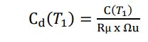 (NBC 105:2020, Cl.6.2(1))

Where,

Elastic Site Spectra(C(T1)) is given by

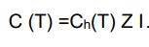 (NBC 105:2020, Cl.4.1.1)

Where,

Ch(T )= 2.25 Spectral Shape Factor (NBC 105:2020, Cl.4.1.2)

I = 1.0Importantfactor(NBC 105:2020, Cl.4.1.5)

Z = 0.35Seismic Zoning Factor(KATHMANDU) (NBC 105:2020, Cl.4.1.4)

So,C(T)=2.25*0.35*1.0

=0.7875

R= The ductility factor=4 (NBC 105:2020, Cl.5.3.1 table 5-2)

u=The overstrength factor=1.5 (NBC 105:2020, Cl.5.4.1 table 5-2)

Cd(*T1*) = 0.7875/(4*1.5)

= **0.1313**

1. **Serviceability Limit State**

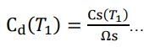 (NBC 105:2020, Cl.6.2(2))

Where,

Cs(T )= 0.2C(T)Elastic Site Spectra (NBC 105:2020, Cl.4.1.2)

= 0.2*0.7875

= 0.1575

    s= The overstrength factor=1.25 (NBC 105:2020, Cl.5.4.2 table 5-2)

So,

Cd(T 1)=0.1575/1.25

=**0.126**

Period of vibration

The fundamental translation period shall be determined by the following two methods.

1. Rayleigh Method
2. Emperical Equations

The time period obtained by empirical equations shall be compared with that obtained by Rayleigh Method and the lesser value of the two shall be adopted for the design action.

**Emperical Equations**

The approximate fundamental natural period of vibration (Ta), inseconds, of a

moment resisting frame building without brick infill panels may be estimated by the empirical expression:

Ta = 0.075 h0.75 for RCMRF building

= 0.085 h0.75 for steel MRF building

Where:

h =Height of building from foundation, in m.

T1= 0.075* 9.1440.75

=0.3944sec.

The approximate fundamental time period as per NBC 105: 2020 CL: 5.1.3 (Page 29)

T1= 1.25*0.3944

= 0.4930 sec

**Rayleigh Method**

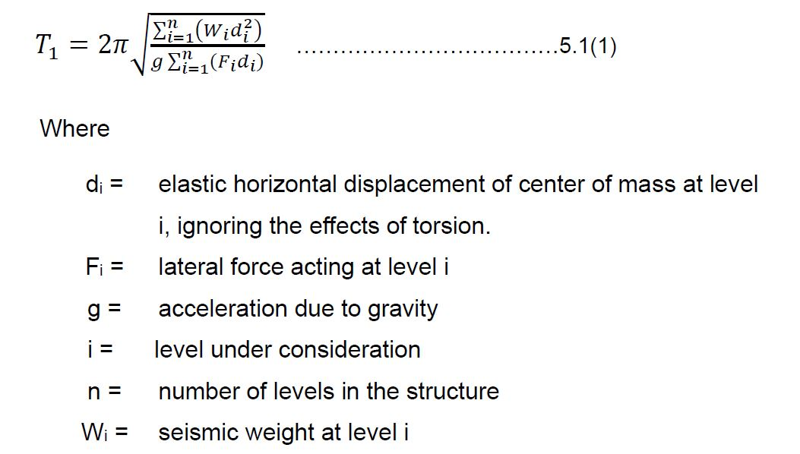

The seismic weight at each level, *Wi*, shall be taken as the sum of the dead loads and the factored seismic live loads between the mid-heights of adjacent stories.

The seismic live load shall be determined as given in **Table 5-1**.

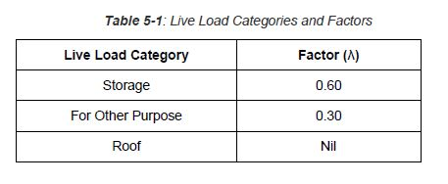

## LOADCOMBINATION

For design of reinforced concrete elements, the following load combinations were considered according to NBC 105:2020 CL 3.6.2:

1. 1.2DL+1.5LL
2. DL+0.3LL+SLSEQX+0.3SLSEQY
3. DL+0.3LL+SLSEQX-0.3SLSEQY
4. DL+0.3LL-SLSEQX+0.3SLSEQY
5. DL+0.3LL-SLSEQX-0.3SLSEQY
6. DL+0.3LL+SLSEQY+0.3SLSEQX
7. DL+0.3LL+SLSEQY-0.3SLSEQX
8. DL+0.3LL-SLSEQY+0.3SLSEQX
9. DL+0.3LL-SLSEQY-0.3SLSEQX
10. DL+0.3LL+ULSEQX+0.3ULSEQY
11. DL+0.3LL+ULSEQX-0.3ULSEQY
12. DL+0.3LL-ULSEQX+0.3ULSEQY
13. DL+0.3LL-ULSEQX-0.3ULSEQY
14. DL+0.3LL+ULSEQY+0.3ULSEQX
15. DL+0.3LL+ULSEQY-0.3ULSEQX
16. DL+0.3LL-ULSEQY+0.3ULSEQX
17. DL+0.3LL-ULSEQY-0.3ULSEQX

Where:

DL=DeadLoad

LL= LiveLoad

ULSEQX= Ultimate limit state Earthquake load inX-direction

ULSEQY= Ultimate limit state Earthquake load inY-direction

SLSEQX= Serviceability limit state Earthquake load inX-direction

SLSEQY= Serviceability limit state Earthquake load inY-direction

## STRUCTURAL ANALYSIS USINGETABS

The building was modeled in structural analysis program ETABS Ver. 20 using frame elements. Slabs were modeled using shell elements to distribute loads on frame elements.3-D Modeling was prepared using this FEM modelingbased software considering beams and columns as FRAME element, and Slab asshell element wherever possible.

**Equivalent Static Method(ESM)** was carried out for its analysis in lateral loading due toearthquake.

## DESIGN METHODS OF STRUCTURALELEMENTS

We have followed Indian Standard Codeof Practicefor Plainand Reinforced Concrete IS: 456-2000 for design of Structural Elements. This incorporates the two methods ofStructural Design of RC structures specified as:

1. Working Stress Method based on the Working loads in conjunction with permissible stresses in thematerials.
2. Limit State Method based on safety and serviceability requirements associated with the design loads and design strengths of the materials. These design loads and design strengths are obtained by applying partial safety factors for characteristic loads and strengths of the materials concrete andsteel.

We have followed the limit state method which is incorporated in IS:456-2000. It is consistent with the new philosophy of design termed limit state approach which was incorporated in the Russian Code – 1954, the British code BS 8110 – 1985 and the American Code ACI 318 – 1989.

## LIMITSTATEMETHOD

* **LimitStates**

The Limit State method of design covers the various forms of failure. There are several limit state at which the structure ceasesto function, themost importantamong thembeing,

1. The limit state of collapse or total failure ofstructure.

It correspondsto themaximum loadcarrying capacity. Violation ofcollapse implies failure. This limit state corresponds to Flexure, Compression, Shear and Torsion.

1. The limit state of serviceability which includes excessive deflection and excessive local damage. Excessive deflection adverselyaffects thefinishes and excessive local damage results in cracking of concrete, which impairs the efficiency, or appearance of the structure.

* DesignEquationsinLimitStateMethod:

1. Singly ReinforcedSections:

The depth of Neutral Axis xu is obtained as Xu = [ ( 0.87Astfy / 0.36 fck b)]

For under Reinforced Sections, the neutral Axis depth Xu is limited to a value of Xu

max < 0.48 d for steel of fy = 415 N /mm2

If the neutral axis depth is less than these limiting values, the ultimate moment is computed

By the equation:

Mu= 0.87 fy Astd [ 1 – { fyAst/ b d fck }]

If the Neutral Depth is equal to the limiting values, then the section is balanced or limiting and the moment capacity is evaluated by theequation.

Mu,lim= 0.36 X u, max / d [ 1 – 0.42 X u,max/ d ] b d 2 fck

Mu,lim= 0.138 fckb d 2 ( for HYSD bars with fy = 415 N /mm2 ) Area of steelina balanced section is givenby:

Ast= [ 0.36 f ck b X u,max/ 0.87 f y]

1. Doubly ReinforcedSections:

Theultimatemoment resistance of sections with compressionreinforcement (doubly reinforced Section) is computed by the equation.

[ M u – Mu,lim] = f scAsc( d – d ’)

|  |  |  |  |
| --- | --- | --- | --- |
| Where, | M u | = | Moment of Resistance of the doubly reinforced sections |
|  | M u,lim | = | Limiting moment of Resistance of a section without |
|  |  |  | Compression reinforcement |
|  | d d’ | =  = | Effective Depth  Depth of Compression Reinforcement from compression face |
|  | fsc | = | Design stress in compression reinforcement |

The total Area of Tension Reinforcement is obtained asAst= Ast1 +Ast2Where,

|  |  |  |  |
| --- | --- | --- | --- |
| Ast1 | = | Total Area of Tensile Reinforcement |  |
| Ast2 | = | Area of Tensile Reinforcement for a singly Reinforced | Section for Mu,kim |
| Asc | = | Ascfsc/ 0.87 fy |  |

The nominal shear stress Tv in beams of uniform depth is obtained as

|  |  |  |
| --- | --- | --- |
| T v | = | Vu / b d |
| Where, Vu B  d | =  =  = | Ultimate shear Force due to design loads Breadth of member  effective depth |

The permissible shear stress Tc in beam depends upon the percentage of longitudinal reinforcement. Where Tc < Tv, minimum shear Reinforcement is given by

Asv / bSv> = 0.4 / fy

If Tv exceeds Tc, but isless thanTc max, then Shear Reinforcements aredesigned to take up the balanced shear Vu – Tcbd

The Strength of Shear Reinforcement Vus is calculated as Vus =0.87 fi Asv d / Sv

1. **ANALYSIS AND DESIGN OF THE STRUCTURALELEMENTS:**

The Structure is analyzed and designed by standard software ETABS Vr.20. It is the World’s most popular and widelyused structuralEngineering Software. It isequipped with the powerful analysis, design, graphics, and visualization capabilities.

General Information on Structural Elements of theBuilding

|  |  |  |  |
| --- | --- | --- | --- |
| **Element** | **Description** | **Grade of Concrete** | **Remarks** |
| Column | 350 mm X 350 mm | M20 |  |
| Main Beam | 350 mm X 230 mm | M20 |  |
| Slab | 125 mm | M20 |  |
| Waist Slab | 125 mm | M20 |  |
| Foundation | Isolated and Strap Footing | M20 | Soil Bearing Capacity is assumed to be 120kN/m2 |

## DETAILING OF THE STRUCTURALELEMENTS:

The Reinforcement detailing of most of theimportant structuralcomponents have been shown in drawing. They confirm with the relevant sections of the IS Codes IS 456-2000, IS 1893-1984, SP-16, and SP –34–1987.

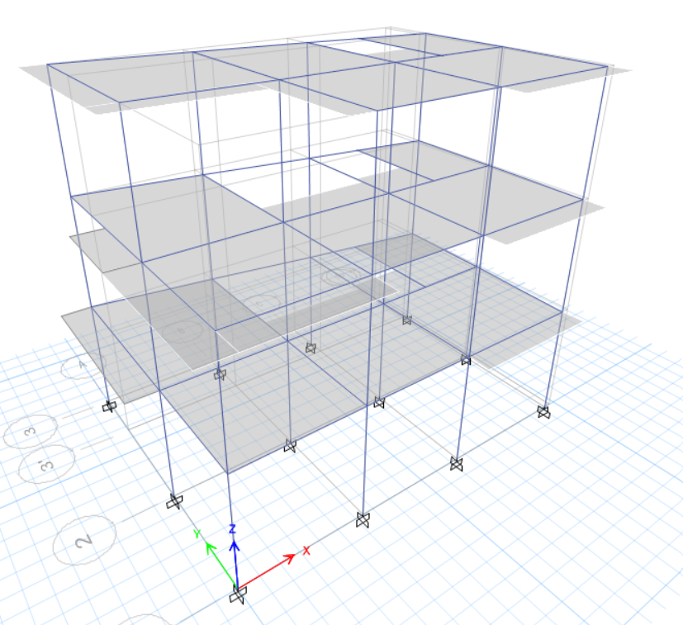

**Frame Structure and Element**

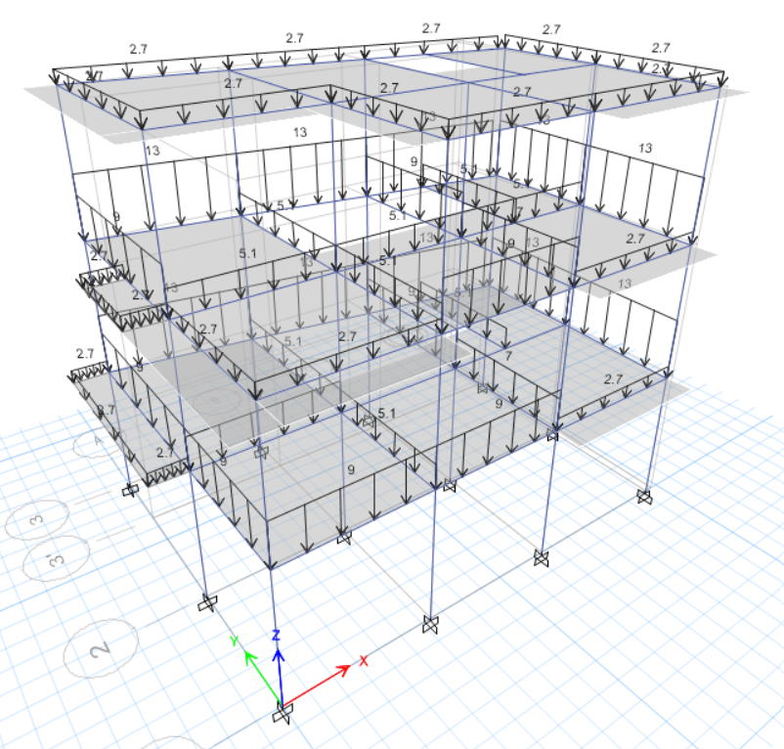

**Wall Dead Load Frames (KN/m)**

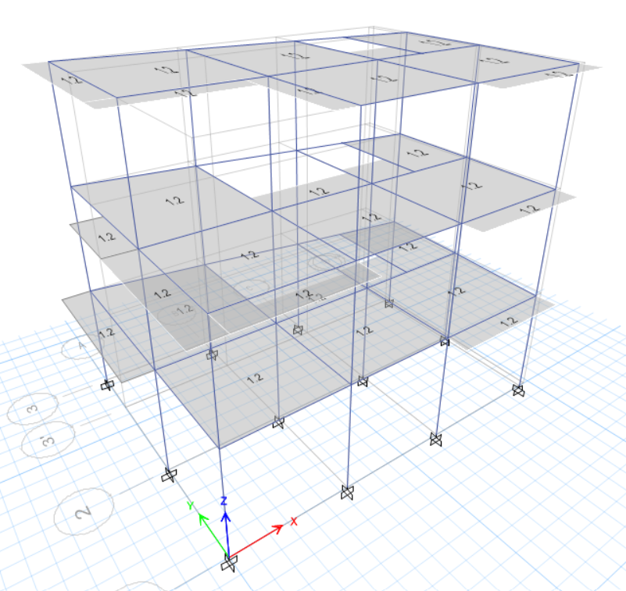

**Floor Finish (KN/m2)**

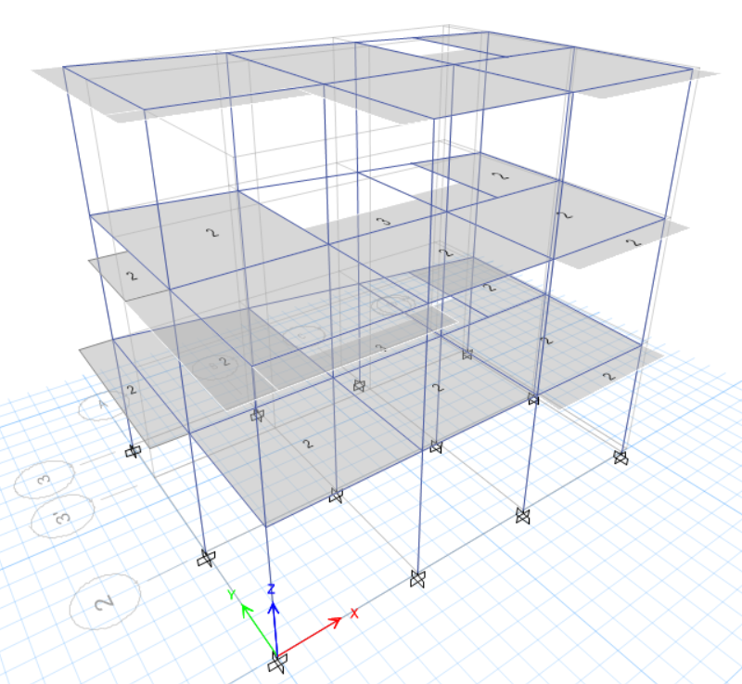

**Live Load (KN/m2)**

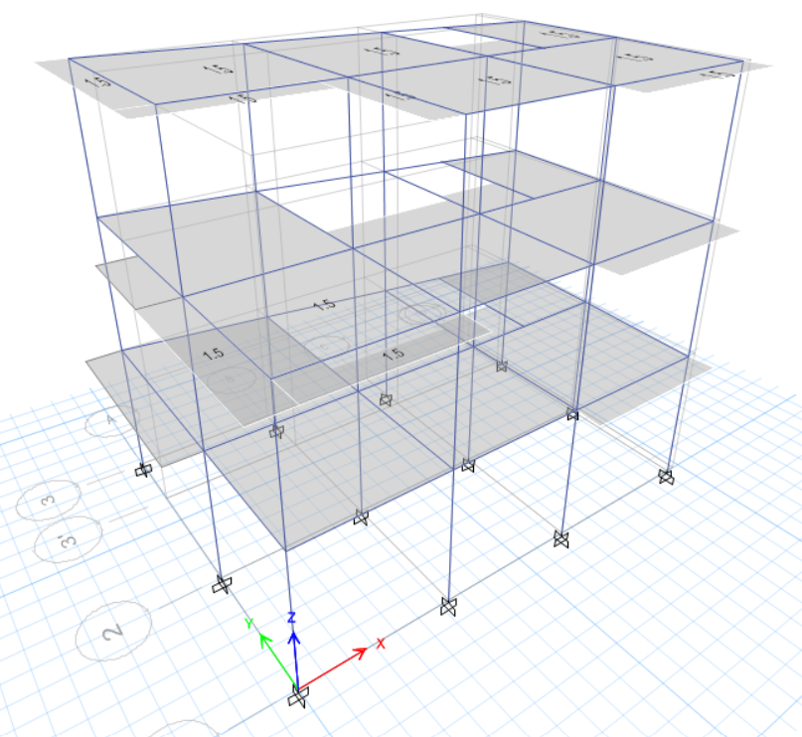

**Roof Live (KN/m2)**

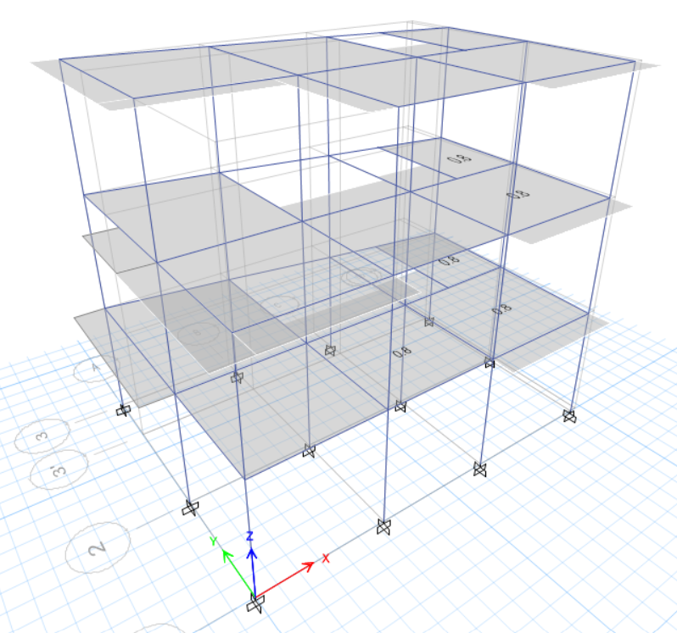

**Wall Load (KN/m2)**

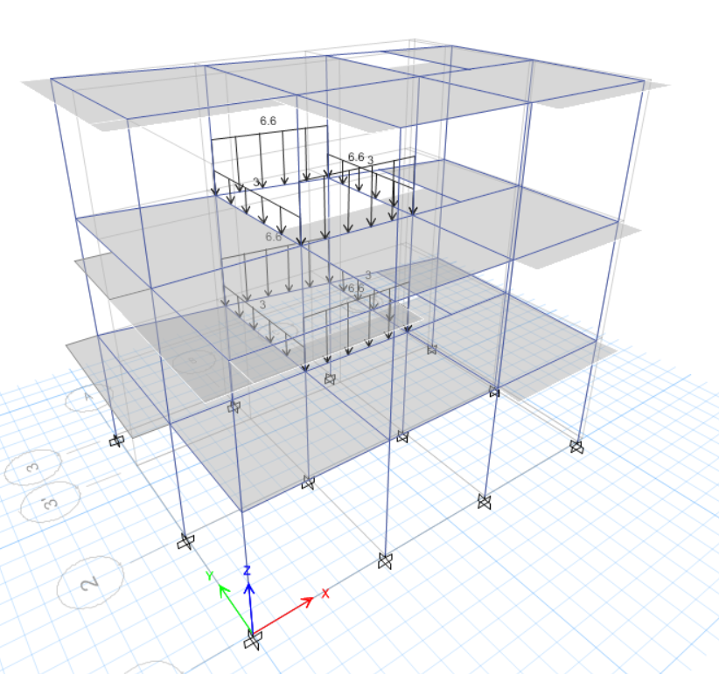

**Stair Dead (KN/m)**

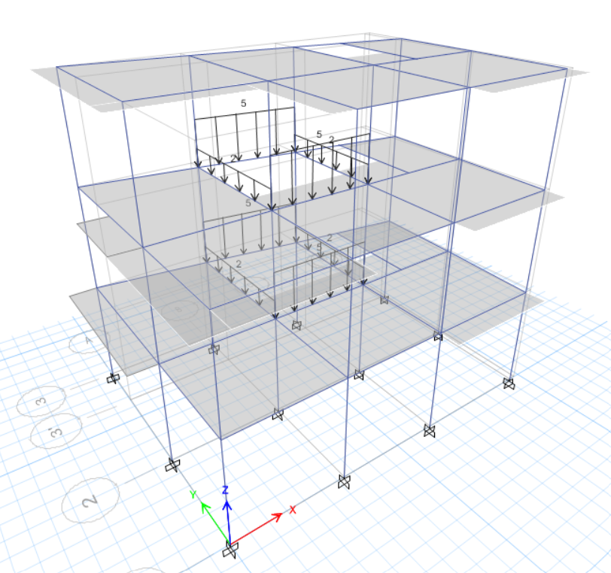

**Stair Live (KN/m)**

**Longitudinal Reinforcements (X - Z Axis) (mm2)**

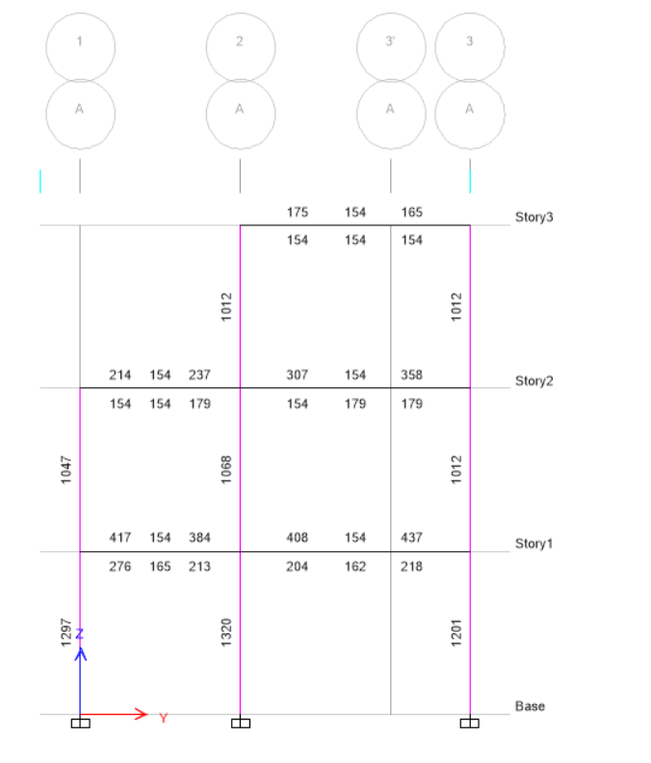

**Grid A-A**

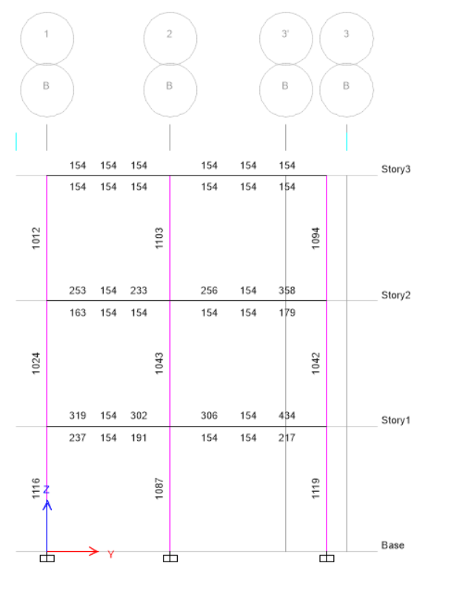

**Grid B-B**

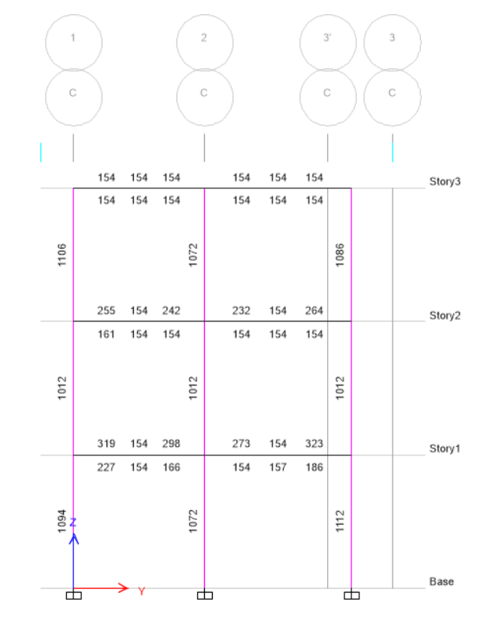

**Grid C-C**

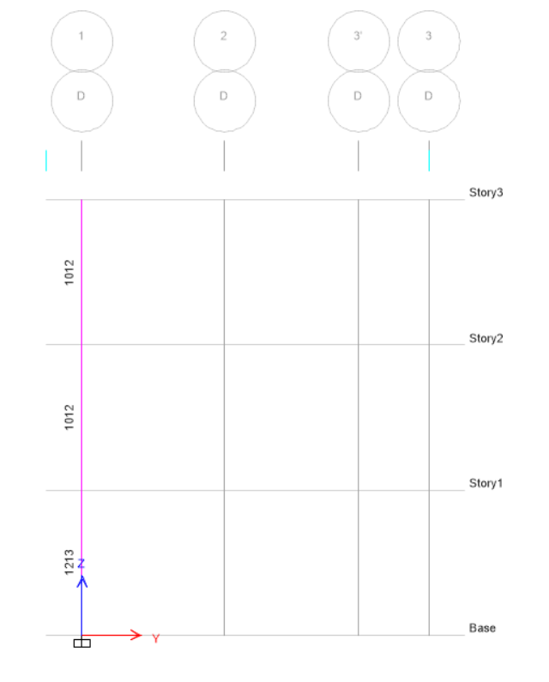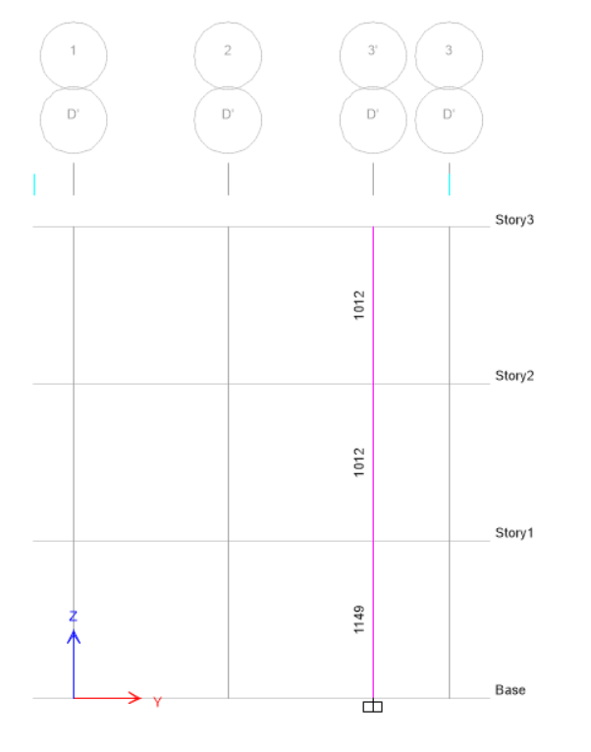

**Grid D-D**

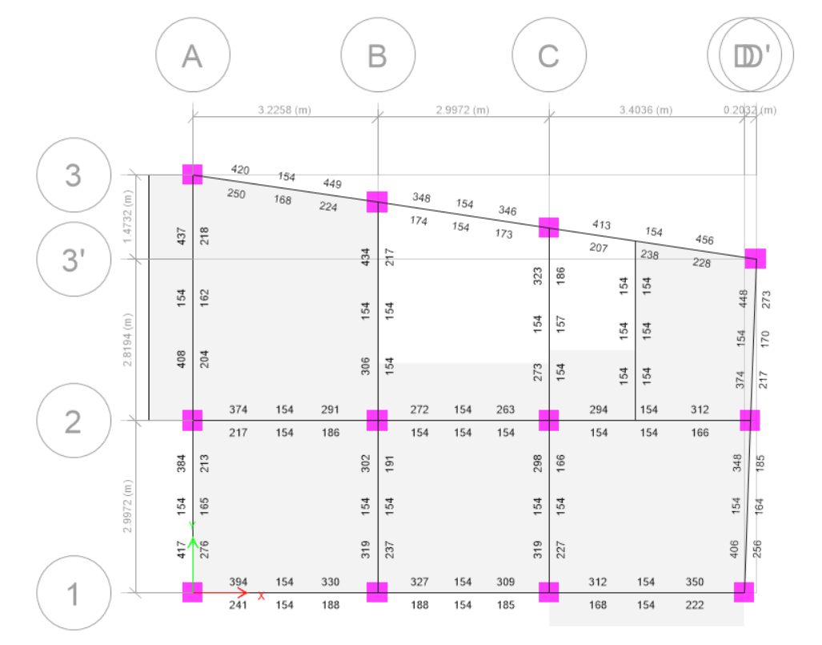

**Beam Reinforcements (X -Y Axis) First Floor Beam**

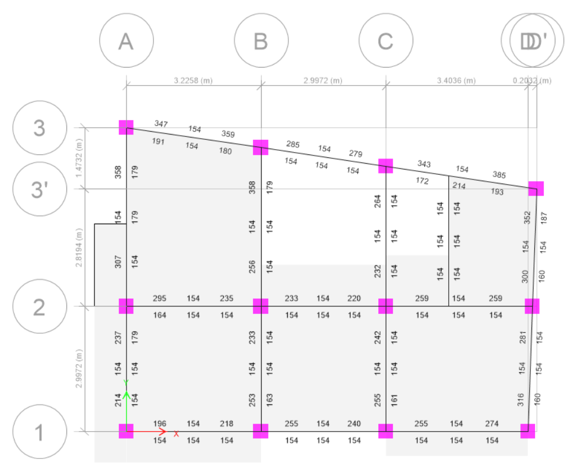

**Beam Reinforcements (X -Y Axis) Second Floor Beam**

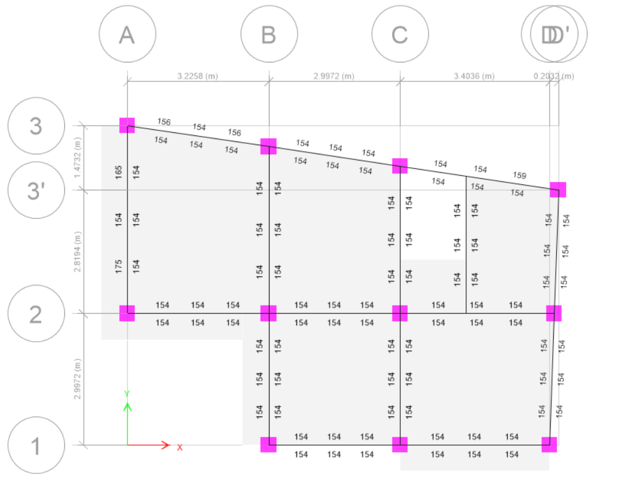

**Beam Reinforcements (X -Y Axis) Third Floor Beam**

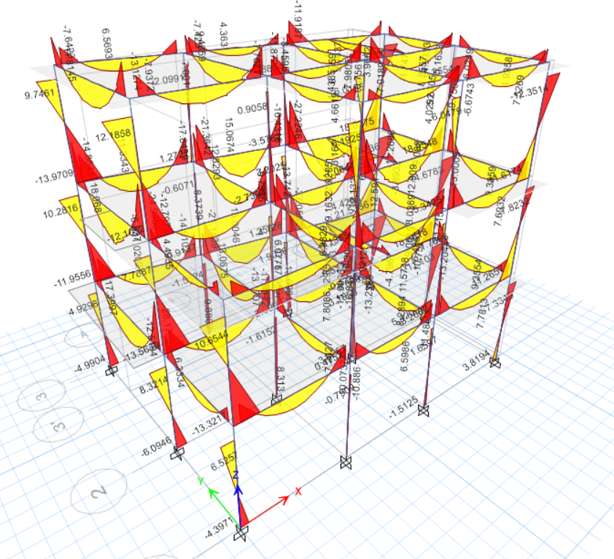

**Bending Moment Diagram**

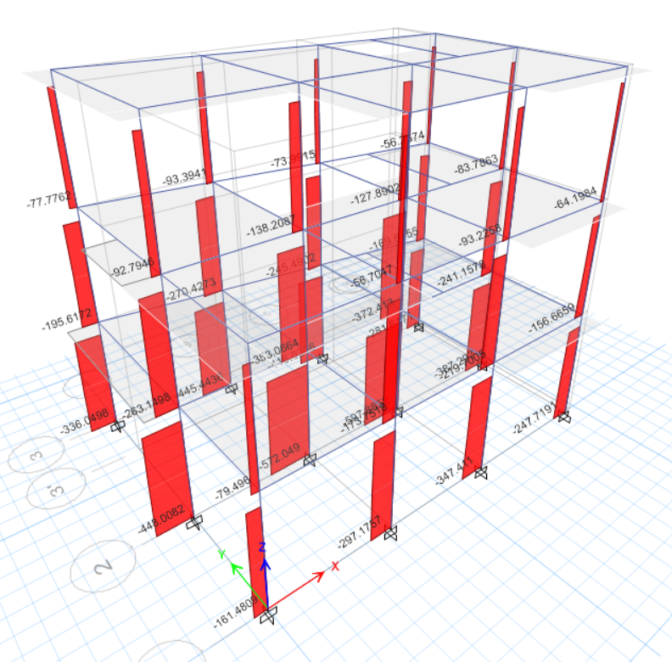

**Axial Force Diagram**

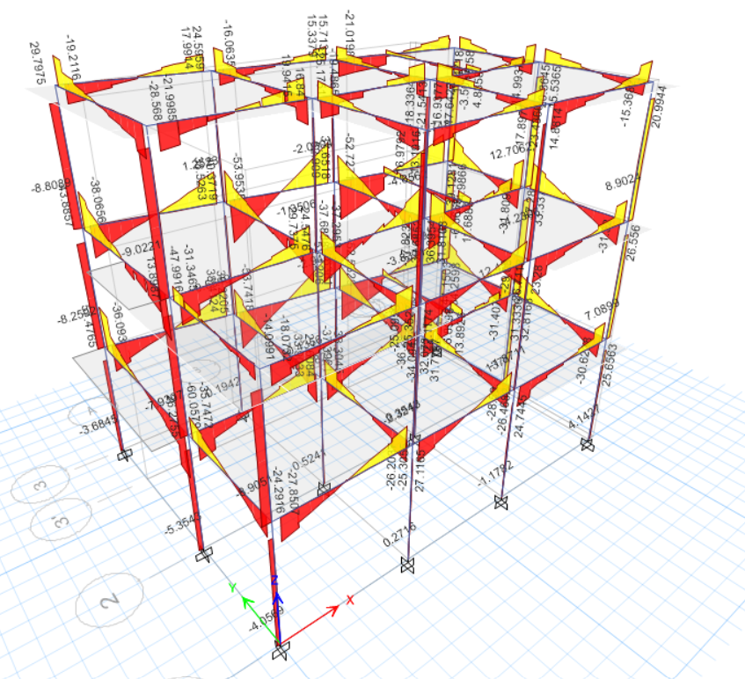

**Shear Force Diagram**

**Seismic Load**

**Horizontal Base shear coefficient**

1. Ultimate Limit State

Cd(*T1*) = 0.7875/(4*1.5)

= 0.1313

1. Serviceability Limit State

Cd(T 1)= 0.1575/1.25

=0.126

Seismic Weight of the Structure=2642.02KN

**Horizontal Seismic Base shear**

V= Cd(*T1*)*W

Where Cd(*T1*)=Horizontal Base shear coefficient

W=Seismic Weight of the Structure

1. Ultimate Limit State Base Shear

V=0.1313*2642.02

=346.9KN

1. Serviceability Limit State Base Shear

V=0.126*2642.02

=332.895KN

**TABLE: Auto Sesmic Load**

|  |  |  |  |  |  |  |  |
| --- | --- | --- | --- | --- | --- | --- | --- |
| **TABLE: Load Pattern Definitions - Auto Seismic - User Coefficient** | | | | | | | |
| **Name** | **Ecc Ratio** | **Top Story** | **Bottom Story** | **C** | **K** | **Weight Used** | **Base Shear** |
|  |  |  |  |  |  | kN | kN |
| EQX SLS | 0.1 | Story3 | Base | 0.1313 | 1 |  |  |
| EQX SLS(1/3) | 0.1 | Story3 | Base | 0.1313 | 1 | 2642.0236 | 346.8977 |
| EQX SLS(2/3) | 0.1 | Story3 | Base | 0.1313 | 1 | 2642.0236 | 346.8977 |
| EQX SLS(3/3) | 0.1 | Story3 | Base | 0.1313 | 1 | 2642.0236 | 346.8977 |
| EQX ULS | 0.1 | Story3 | Base | 0.126 | 1 |  |  |
| EQX ULS(1/3) | 0.1 | Story3 | Base | 0.126 | 1 | 2642.0236 | 332.895 |
| EQX ULS(2/3) | 0.1 | Story3 | Base | 0.126 | 1 | 2642.0236 | 332.895 |
| EQX ULS(3/3) | 0.1 | Story3 | Base | 0.126 | 1 | 2642.0236 | 332.895 |
| EQY SLS | 0.1 | Story3 | Base | 0.1313 | 1 |  |  |
| EQY SLS(1/3) | 0.1 | Story3 | Base | 0.1313 | 1 | 2642.0236 | 346.8977 |
| EQY SLS(2/3) | 0.1 | Story3 | Base | 0.1313 | 1 | 2642.0236 | 346.8977 |
| EQY SLS(3/3) | 0.1 | Story3 | Base | 0.1313 | 1 | 2642.0236 | 346.8977 |
| EQY ULS | 0.1 | Story3 | Base | 0.126 | 1 |  |  |
| EQY ULS(1/3) | 0.1 | Story3 | Base | 0.126 | 1 | 2642.0236 | 332.895 |
| EQY ULS(2/3) | 0.1 | Story3 | Base | 0.126 | 1 | 2642.0236 | 332.895 |
| EQY ULS(3/3) | 0.1 | Story3 | Base | 0.126 | 1 | 2642.0236 | 332.895 |

|  |  |  |  |  |  |  |  |  |
| --- | --- | --- | --- | --- | --- | --- | --- | --- |
| **TABLE: Modal Participating Mass Ratios** | | | | | | | | |
| **Case** | **Mode** | **Period** | **UX** | **UY** | **UZ** | **SumUX** | **SumUY** | **SumUZ** |
|  |  | **sec** |  |  |  |  |  |  |
| Modal | 1 | 0.624 | 0.422 | 0.3882 | 0 | 0.422 | 0.3882 | 0 |
| Modal | 2 | 0.616 | 0.3605 | 0.4658 | 0 | 0.7825 | 0.8539 | 0 |
| Modal | 3 | 0.525 | 0.0747 | 0.0002 | 0 | 0.8572 | 0.8541 | 0 |
| Modal | 4 | 0.203 | 0.0241 | 0.0797 | 0 | 0.8813 | 0.9339 | 0 |
| Modal | 5 | 0.197 | 0.0832 | 0.0279 | 0 | 0.9645 | 0.9618 | 0 |
| Modal | 6 | 0.174 | 0.0041 | 0.0057 | 0 | 0.9686 | 0.9675 | 0 |
| Modal | 7 | 0.124 | 0.0071 | 0.023 | 0 | 0.9757 | 0.9904 | 0 |
| Modal | 8 | 0.122 | 0.023 | 0.0082 | 0 | 0.9987 | 0.9986 | 0 |
| Modal | 9 | 0.109 | 0.0013 | 0.0014 | 0 | 1 | 1 | 0 |
| Modal | 10 | 0.006 | 0 | 0 | 0 | 1 | 1 | 0 |
| Modal | 11 | 0.005 | 0 | 0 | 0 | 1 | 1 | 0 |
| Modal | 12 | 0.005 | 0 | 0 | 0 | 1 | 1 | 0 |
| Modal | 13 | 0.624 | 0.422 | 0.3882 | 0 | 0.422 | 0.3882 | 0 |
| Modal | 14 | 0.616 | 0.3605 | 0.4658 | 0 | 0.7825 | 0.8539 | 0 |
| Modal | 15 | 0.525 | 0.0747 | 0.0002 | 0 | 0.8572 | 0.8541 | 0 |

## DESIGN

## COLUMNDESIGN

Ground Floor=A2

ETABS Concrete Frame Design

IS 456:2000 + IS 13920:2016 Column Section Design (Summary)

|  |
| --- |
| Desert.jpg |

Column Element Details

| Level | Element | Unique Name | Section ID | Combo ID | Station Loc | Length (mm) | LLRF | Type |
| --- | --- | --- | --- | --- | --- | --- | --- | --- |
| Story1 | C2 | 2 | Column 14" X 14" | dl+0.3ll-slseqy-0.3slseqx | 0 | 3048 | 0.733 | Ductile Frame |

Section Properties

| b (mm) | h (mm) | dc (mm) | Cover (Torsion) (mm) |
| --- | --- | --- | --- |
| 355.6 | 355.6 | 56 | 30 |

Material Properties

| Ec (MPa) | fck (MPa) | Lt.Wt Factor (Unitless) | fy (MPa) | fys (MPa) |
| --- | --- | --- | --- | --- |
| 22360.68 | 20 | 1 | 500 | 500 |

Design Code Parameters

| ɣC | ɣS |
| --- | --- |
| 1.5 | 1.15 |

Axial Force and Biaxial Moment Design ForPu , Mu2 , Mu3

| Design Pu  kN | Design Mu2  kN-m | Design Mu3  kN-m | Minimum M2  kN-m | Minimum M3  kN-m | Rebar Area  mm² | Rebar %  % |
| --- | --- | --- | --- | --- | --- | --- |
| 276.7545 | -81.103 | -20.9068 | 5.5351 | 5.5351 | 1320 | 1.04 |

Axial Force and Biaxial Moment Factors

|  | K Factor  Unitless | Length  mm | Initial Moment  kN-m | Additional Moment  kN-m | Minimum Moment  kN-m |
| --- | --- | --- | --- | --- | --- |
| Major Bend(M3) | 0.663232 | 2692.4 | -8.6548 | 0 | 5.5351 |
| Minor Bend(M2) | 0.643508 | 2692.4 | -33.5316 | 0 | 5.5351 |

Shear Design for Vu2 , Vu3

|  | Shear Vu  kN | Shear Vc  kN | Shear Vs  kN | Shear Vp  kN | Rebar Asv /s  mm²/m |
| --- | --- | --- | --- | --- | --- |
| Major, Vu2 | 21.4085 | 73.3399 | 42.6146 | 21.4085 | 394.16 |
| Minor, Vu3 | 44.1719 | 73.3399 | 42.6146 | 35.8741 | 394.16 |

Joint Shear Check/Design

|  | Joint Shear  Force  kN | Shear  VTop  kN | Shear  Vu,Tot  kN | Shear  Vc  kN | Joint  Area  cm² | Shear  Ratio  Unitless |
| --- | --- | --- | --- | --- | --- | --- |
| Major Shear, Vu2 | N/N | N/N | N/N | N/N | N/N | N/N |
| Minor Shear, Vu3 | N/N | N/N | N/N | N/N | N/N | N/N |

(1.4) Beam/Column Capacity Ratio

| Major Ratio | Minor Ratio |
| --- | --- |
| N/N | N/N |

Additional Moment Reduction Factor k (IS 39.7.1.1)

| Ag  cm² | Asc  cm² | Puz  kN | Pb  kN | Pu  kN | k  Unitless |
| --- | --- | --- | --- | --- | --- |
| 1264.5 | 13.2 | 1633.1081 | 461.9782 | 276.7545 | 1 |

Additional Moment (IS 39.7.1)

|  | Consider  Ma | Length  Factor | Section  Depth (mm) | KL/Depth  Ratio | KL/Depth  Limit | KL/Depth  Exceeded | Ma  Moment (kN-m) |
| --- | --- | --- | --- | --- | --- | --- | --- |
| Major Bending (M3 ) | Yes | 0.883 | 355.6 | 5.022 | 12 | No | 0 |
| Minor Bending (M2 ) | Yes | 0.883 | 355.6 | 4.872 | 12 | No | 0 |

Notes:

N/A: Not Applicable

N/C: Not Calculated

N/N: Not Needed

## BEAMDESIGN

GroundFloor-A3-B3

ETABS Concrete Frame Design

IS 456:2000 + IS 13920:2016 Beam Section Design (Summary)

|  |
| --- |
| Desert.jpg |

Beam Element Details

| Level | Element | Unique Name | Section ID | Combo ID | Station Loc | Length (mm) | LLRF | Type |
| --- | --- | --- | --- | --- | --- | --- | --- | --- |
| Story1 | B3 | 12 | Beam 9"x14" | dl+0.3ll+slseqx+0.3slseqy | 3084 | 3261.8 | 1 | Ductile Frame |

Section Properties

| b (mm) | h (mm) | bf (mm) | ds (mm) | dct (mm) | dcb (mm) |
| --- | --- | --- | --- | --- | --- |
| 228.6 | 355.6 | 228.6 | 0 | 41 | 41 |

Material Properties

| Ec (MPa) | fck (MPa) | Lt.Wt Factor (Unitless) | fy (MPa) | fys (MPa) |
| --- | --- | --- | --- | --- |
| 22360.68 | 20 | 1 | 500 | 500 |

Design Code Parameters

| ɣC | ɣS |
| --- | --- |
| 1.5 | 1.15 |

Factored Forces and Moments

| Factored  Mu3  kN-m | Factored  Tu  kN-m | Factored  Vu2  kN | Factored  Pu  kN |
| --- | --- | --- | --- |
| -36.256 | 10.2662 | 50.7771 | 0.7248 |

Design Moments, Mu3& Mt

| Factored  Moment  kN-m | Factored  Mt  kN-m | Positive  Moment  kN-m | Negative  Moment  kN-m |
| --- | --- | --- | --- |
| -36.256 | 15.4328 | 0 | -51.6888 |

Design Moment and Flexural Reinforcement for Moment, Mu3& Tu

|  | Design  -Moment  kN-m | Design  +Moment  kN-m | -Moment  Rebar  mm² | +Moment  Rebar  mm² | Minimum  Rebar  mm² | Required  Rebar  mm² |
| --- | --- | --- | --- | --- | --- | --- |
| Top (+2 Axis) | -51.6888 |  | 449 | 0 | 449 | 154 |
| Bottom (-2 Axis) |  | 0 | 224 | 0 | 0 | 224 |

Shear Force and Reinforcement for Shear, Vu2& Tu

| Shear Ve  kN | Shear Vc  kN | Shear Vs  kN | Shear Vp  kN | Rebar Asv /s  mm²/m |
| --- | --- | --- | --- | --- |
| 65.6898 | 0 | 137.5441 | 41.9899 | 1211.53 |

Torsion Force and Torsion Reinforcement for Torsion, Tu& VU2

| Tu  kN-m | Vu  kN | Core b1  mm | Core d1  mm | Rebar Asvt /s  mm²/m |
| --- | --- | --- | --- | --- |
| 10.2662 | 50.7771 | 166.6 | 293.6 | 773.3 |

## SLABDESIGN

|  |  |  |  |  |  |  |
| --- | --- | --- | --- | --- | --- | --- |
| **Design of Two way Slab by Limit State Method** | | | | |  |  |
| (As per IS 456:2000) | | | | |  |  |
|  |  |  |  |  |  |  |
|  |  |  |  |  |  |  |
|  |  |  |  |  |  |  |
| **1** | **Data** |  |  |  |  |  |
|  | Longer span of slab, ly | 4.290 | m |  |  |  |
|  | Shorter span of slab, lx | 3.225 | m |  |  |  |
|  |  |  |  |  |  |  |
|  | Materials used |  |  |  |  |  |
|  | Concrete | M20 | 20 | N/mm2 |  |  |
|  | Steel | Fe500 | 500 | N/mm2 |  |  |
|  |  |  |  |  |  |  |
|  |  |  |  |  |  |  |
| **2** | **Effective span** |  |  |  |  |  |
|  | Longer span of slab, ly | 4.114 | m |  |  |  |
|  | Shorter span of slab, lx | 3.049 | m |  |  |  |
|  | ly/lx | 1.349 |  |  |  |  |
|  | type of slab | <2 two way slab | |  |  |  |
|  | Support Condition : |  |  |  |  |  |
|  | **One Short Edge Discontinuous** |  |  |  |  |  |
|  |  |  |  |  |  |  |
|  |  |  |  |  |  |  |
| **3** | **Calculation of loads** |  |  |  |  |  |
|  | **i) Dead load** |  |  |  |  |  |
| i | Slab thickness | 127 | mm |  |  |  |
|  | Self weight of concrete | 25 | KN/m3 |  |  |  |
|  | Dead load of slab = 25 * 0.125 | 3.175 | KN/m2 |  |  |  |
| ii | Screeding thickness | 30 | mm |  |  |  |
|  | Self weight of screeding | 20.4 | KN/m3 |  |  |  |
|  | Dead load of screeding = 20.4 * 0.03 | 0.612 | KN/m2 |  |  |  |
| iii | marble flooring thickness | 19 | mm |  |  |  |
|  | Self weight of marble | 27 | KN/m3 |  |  |  |
|  | Dead load of marble = 27 * 0.019 | 0.513 | KN/m2 |  |  |  |
| iv | Cement plaster thickness | 12.5 | mm |  |  |  |
|  | Self weight of plaster | 20.4 | KN/m3 |  |  |  |
|  | Dead load of plaster = 20.4 * 0.0125 | 0.255 | KN/m2 |  |  |  |
|  | **Total dead load on slab** | **4.555** | **KN/m2** |  |  |  |
|  |  |  |  |  |  |  |
|  | **ii) Live load** |  |  |  |  |  |
|  | For Residential Building | 2 | KN/m2 |  |  |  |
|  |  |  |  |  |  |  |
|  | **Total design load (DL+LL)** | **6.555** | **KN/m2** |  |  |  |
|  | Factored load = 1.5 * design load | 9.8325 | KN/m2 |  |  |  |
|  |  |  |  |  |  |  |
| **4** | **Calculation of moments** |  |  |  |  |  |
|  | As per code, | Shorter Direction | | Longer Direction | |  |
|  | -ve moment at support | Support, αx1 | 0.053 | Support, αy1 | 0.037 |  |
|  | +ve moment at mid | mid, αx2 | 0.040 | mid, αy2 | 0.028 |  |
|  | Along shorter span, |  |  |  |  |  |
|  | Mx = αx1*wu*lx | 5.446 | KNm |  |  |  |
|  | My = αy1*wu*lx | 3.804 | KNm |  |  |  |
|  | Along longer span, |  |  |  |  |  |
|  | Mx = αx2*wu*lx | 4.111 | KNm |  |  |  |
|  | My = αy2*wu*lx | 2.879 | KNm |  |  |  |
|  |  |  |  |  |  |  |
| **5** | **Depth Calculation** |  |  |  |  |  |
|  | Minimum depth of slab is calculated considering maximum bending moment | | | |  |  |
|  | Maxm bending moment | 5.446 |  |  |  |  |
|  | Depth required, |  |  |  |  |  |
|  | d=sqrt(Mu/(0.36*xumax/d)*(1-0.42*xumax/d)*b*fck) | |  |  |  |  |
|  |  |  |  |  |  |  |
|  | overall depth, D=d+φ/2+clear cover) |  | mm |  |  |  |
|  | For safe design, adopting depth of slab | 125 | mm |  |  |  |
|  | Effective depth | 96 | mm |  |  |  |
|  |  |  |  |  |  |  |
| **6** | **Reinforcement Calculation** | Main Bar | Dist. Bar | |  |  |
| provide the reinforcement of dia | | 8 | 8 | mm |  |  |
| S. No. | Description | Shorter Direction | | Longer Direction | |  |
| Support | mid | Support | mid |  |
| 1 | αx & αy | 0.053 | 0.040 | 0.037 | 0.028 |  |
| 2 | BM | 5.45 | 4.11 | 3.80 | 2.88 |  |
| 3 | Ast required | 120.39 | 90.22 | 83.35 | 62.77 |  |
| 4 | Ast min | 152.40 | 152.40 | 152.40 | 152.40 |  |
| 5 | Spacing reqd | 329.96 | 329.96 | 329.96 | 329.96 |  |
| 6 | Spacing prov. | 150.00 | 150.00 | 150.00 | 150.00 |  |
| 7 | Ast provided | 335.24 | 335.24 | 335.24 | 335.24 |  |
| 8 | % of steel provided | 0.26 | 0.26 | 0.26 | 0.26 |  |
|  |  |  |  |  |  |  |
| **7** | **Check** |  |  |  |  |  |
| **7.1** | **Minimum reinforcement** |  |  |  |  |  |
|  | Min Ast = 0.12% bD | 150 | mm2 | < Ast provided in all sections | | |
|  |  |  |  |  |  |  |
| **7.2** | **Check for deflection** |  |  |  |  |  |
|  | From deflection control criteria |  |  |  |  |  |
|  | lx/d < (l/d)basic*αβγ | where |  |  |  |  |
|  | lx/d | 28.4906542 |  |  |  |  |
|  | α = modification factor for tension reinforcement | |  |  | fig 4 |  |
|  | β = modification factor for compression reinf. | | 1 |  | fig 5 |  |
|  | γ = reduction factor for ratios of span to eff. depth in flanged beam | | 1 |  | fig 6 |  |
|  | (l/d)basic = | 23 |  |  | of IS 456 |  |
|  | For α, |  |  |  |  |  |
|  | fs = 0.58*fy*(Ast required/Ast provided) | 131.835 | N/mm2 |  |  |  |
|  | % of tensional reinforcement | 0.264 |  |  |  |  |
|  | α | 2 |  |  |  |  |
|  | now, (l/d)basic*αβγ | 46 |  | OK Safe |  |  |
|  | Since, lx/d < (l/d)basic*αβγ | SAFE |  |  |  |  |
|  |  |  |  |  |  |  |
| **7.3** | **Check for Shear** |  |  |  |  |  |
|  | Shear is checked along short span. |  |  |  |  |  |
|  | Maximum shear force, Vumax = w*lx/2 | 16.862 | KN |  |  |  |
|  | Normal shear stress, τv = V/bd | 0.158 | N/mm2 |  |  |  |
|  | % of steel provided = 100*Ast provided/bD | 0.157 |  |  |  |  |
|  | Shear capacity of section without reinforcement |  |  |  |  |  |
|  | From table 19, |  |  |  |  |  |
|  | τc | 0.285 | N/mm2 |  |  |  |
|  | Shear strength, τ'c = k*τc |  |  |  |  |  |
|  | For slab thickness 125mm, k | 1.3 |  |  |  |  |
|  | Shear strength, τ'c | 0.371 | N/mm2 |  |  |  |
|  | Since, τ'c>τv | OK Safe |  |  |  |  |
|  |  |  |  |  |  |  |
| **8** | **Results** |  |  |  |  |  |
|  | Overall depth of slab = | 125 | mm |  |  |  |
|  | Main bar along short span at support | 8mm ø @ 150mm c/c | |  |  |  |
|  | Main bar along short span at mid | 8mm ø @ 150mm c/c | |  |  |  |
|  | Distribution Bar along long span at support | 8mm ø @ 150mm c/c | |  |  |  |
|  | Distribution bar along long span at mid | 8mm ø @ 150mm c/c | |  |  |  |

## FOUNDATIONDESIGN

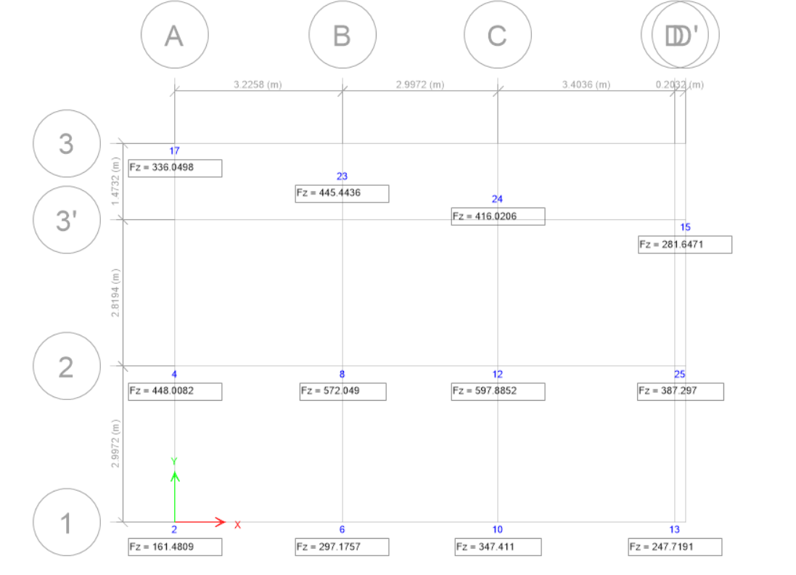

Joint Reaction1.5(DL+LL)

|  |  |  |  |  |  |  |
| --- | --- | --- | --- | --- | --- | --- |
| **Isolated Footing Design** | | | | |  |  |
| **Foundation Type :** | | **F1** |  |  |  |  |
| Required Data | |  |  |  |  |  |
| size of colunm= | |  |  |  |  |  |
|  | l = |  | 0.35 | m |  |  |
|  | b = |  | 0.35 | m |  |  |
| Bearing Capacity of Soil= | | | 120 | KN/m² |  |  |
| Strength of Steel (fy)= | | | 500 | N/mm² |  |  |
| Strength of Concrete (fck)= | | | 20 | N/mm² | ( M20 ) |  |
| Factor Load= | |  | 597.89 |  |  |  |
| Axial Load = | |  | 398.59 | KN |  |  |
|  |  |  |  |  |  |  |
| Approximate area of footing= | | | 3.32 | m² |  |  |
| Weight of footing including earth= | | | 99.65 |  |  |  |
| Axial Load = | |  | 398.59 | KN |  |  |
| Total weight on soil= | | | **498.24** | KN |  |  |
| Actual Area= | |  | 4.15 | m² |  |  |
| Size of Square Footing = | | | 2.038 |  | 6.68346 |  |
|  |  |  |  |  |  |  |
| Adopted size= | |  |  |  |  |  |
|  | L = |  | 2.13 | m | 6.99 |  |
|  | B = |  | 2.13 | m |  |  |
| Actual area of footing = | | | 4.5369 | m² |  |  |
| Net Pressure acting upwads = | | | 131.78 | KN/m² |  |  |
| B. M. at the face of column about an axis = | | | | 111.17 | KN-m |  |
|  | | |  |  |  |  |
|  |  |  |  |  |  |  |
| The effective depth required is given by | | | |  |  |  |
|  |  |  | BM= 0.138 fck*bd^2 | |  |  |
|  |  |  |  |  |  |  |
|  |  | d= | 137.51 | mm |  |  |
|  |  |  |  |  |  |  |
| Adopt d = 2 to 3 Times of calculated value of d for Shear considerations. | | | | | | |
|  |  |  |  |  |  |  |
|  |  | Adop. d= | 350 | mm |  |  |
|  |  | D= | 400 | mm |  |  |
| **Check for one-way Shear action** | | | |  |  |  |
| The critical section is taken at distance d away from the face of column | | | | | | |
|  |  |  |  |  |  |  |
| Shear force Vu= | | 151.58 | KN |  |  |  |
| Nominal shear stress (Tv) = | | | Vu/b*d = | 0.20 | N/mm² |  |
|  |  |  |  |  |  |  |
| Allowable Shear Stress of Concrete for pt% of Steel < = 0.15 & | | | | | ( M20 ) | 0.28 |
| For 0.165% | Tc = | 0.292 | N/sq.mm | (From IS 456: 2000, table 19) | | |
|  |  | Hence, | **OK** |  |  |  |
|  | Tc should be equal to or greater than Tv | | | |  |  |
|  |  |  |  |  |  |  |
| **Check for two-way Shear action** | | | |  |  |  |
| The critical section is taken at a distance of 0.5d away from the face ofcolumn , | | | | | | |
|  | Shear force Vu= | | 533.31 | KN |  |  |
| Nominal Shear Stress(Tv) = Vu/b'd (Where b' is the periphery of critical section ) | | | | | | |
|  | and | b' = | 2800 | mm |  |  |
|  |  |  |  |  |  |  |
| So, Nominal Shear Stress(Tv) = | | | 0.54 | N/mm² |  |  |
| Shear Strength of concrete is | | |  |  |  |  |
| Tc = | 1.12 | N/sq.mm |  |  |  |  |
| T'c = | Ks*Tc | Where Ks=(0.5+Bc) | |  |  |  |
|  |  | Bc=length of shorter side of column/length of longer side of column | | | | |
|  |  | Bc= | 1 |  |  |  |
|  |  | Ks= | 1.5 | should not be greater than 1 | | |
|  |  | Take(Ks)= | 1 |  |  |  |
|  |  | T'c= | 1.12 | N/mm² |  |  |
|  | Hence, | | **OK** | T'c should be greater than Tv | | |
|  |  |  |  |  |  |  |
| **Area of Steel Calculation,** | | | |  |  |  |
| Area of Steel is given by formula, BM = 0.87* fy* At*{d-fy*At/(fck*b)} | | | | | | |
| Then, |  |  |  |  |  |  |
|  | Ast = | 748.99 | sq.mm | > Ast min | = 0.12% of b * d | |
|  | Ast per m = | 351.64 |  |  | 420 | mm² |
|  | Req. Area of steel = | | 420.00 | mm² |  |  |
|  | % of steel= | | 0.100 |  |  |  |
| Steel requied as | | 12 | mm bar @ | 269.28 | mm c/c distance. | |
|  |  |  |  |  |  |  |
| Provide Steel as = | | 12 | mm bar @ | 150 | mm c/c distance. | |
|  | Provided steel = | | 753.98 | mm² |  |  |
|  |  |  |  | Hence Ok. |  |  |

## ACCEPTABILITY CRITERIA

## 13.1 STORYDRIFT

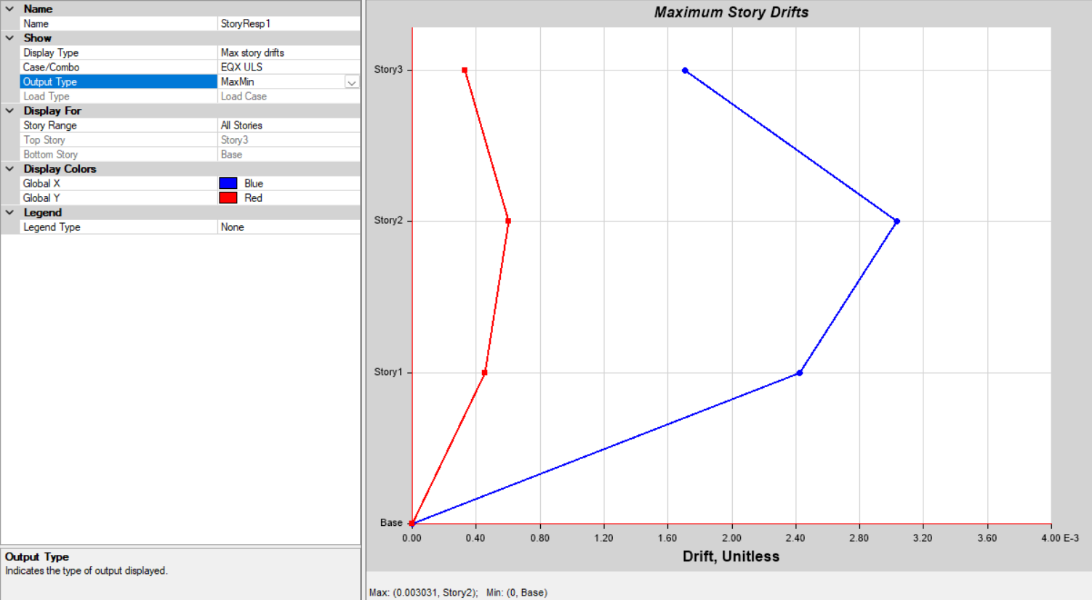

Inter-storeyDrift(Load case:ULSx)

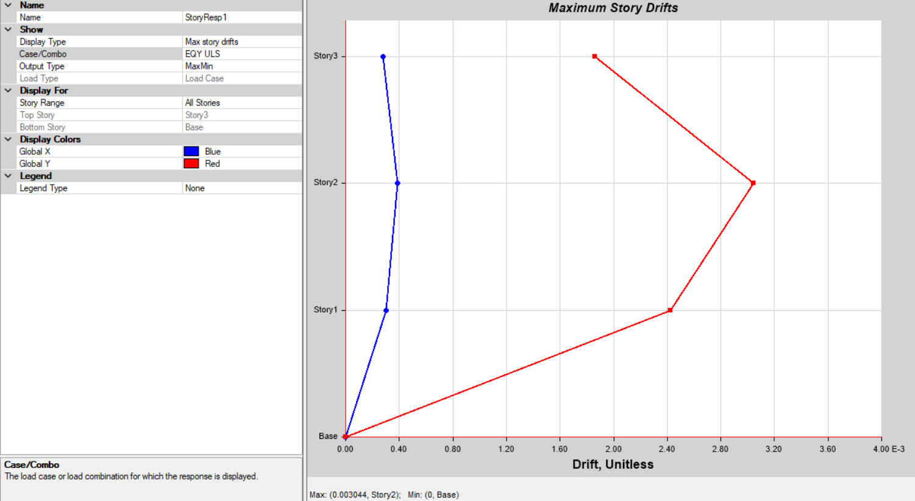

Inter-storeyDrift(Load case:ULSy)

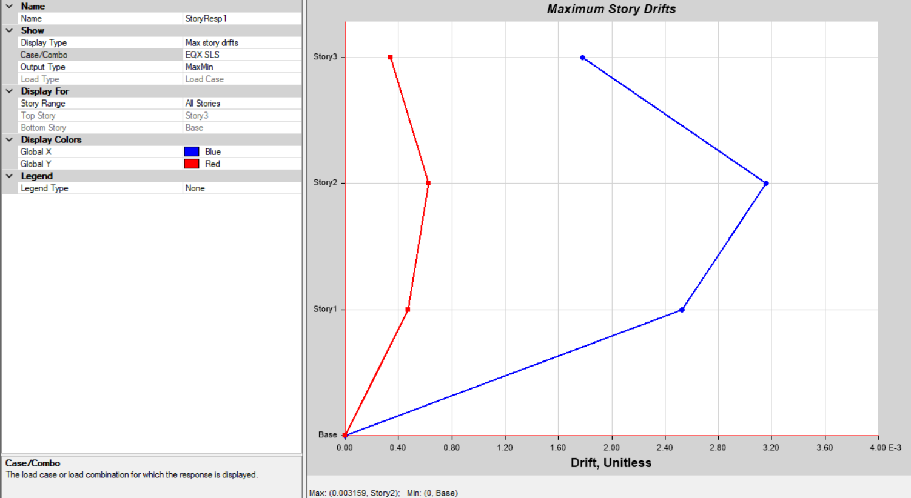

Inter-storeyDrift(Load case:SLSx)

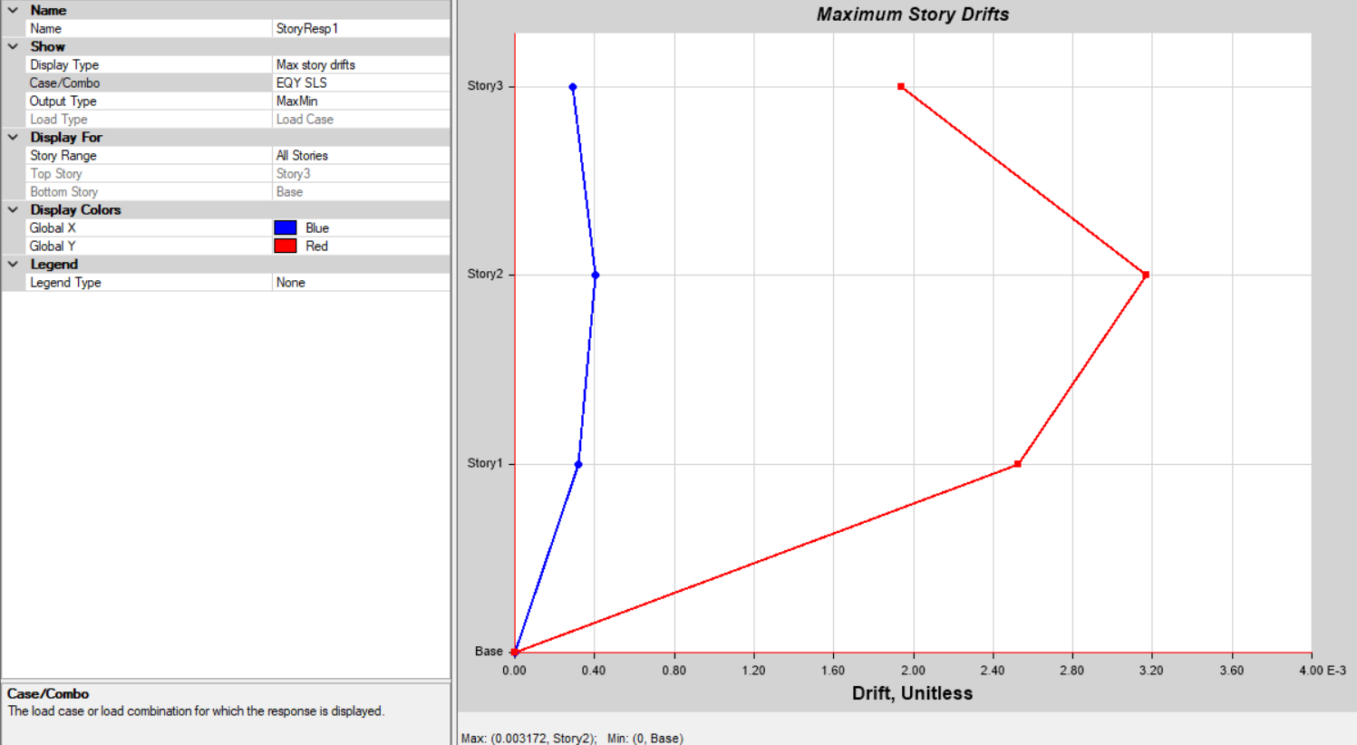

Inter-storeyDrift(Load case:SLSy)

To control overall deflection, the criteria given in clause 5.6.1 of NBC 105:2020 is applied. The maximum design horizontal deflection in any story due to the design lateral force shall be determined by multiplying the horizontal deflection found from Equivalent Static Method or Modal Response Spectrum Method by the Ductility factor (Rμ). For ultimate limit state and for serviceability limit state it shall be taken as equal to the horizontal deflections calculated either by Equivalent Static Method or Modal Response Spectrum Methods.

Furthermore, the drift shall not exceed maximum drift in the model. The maximum drift for ultimate limit state is 0.003044*4=0.012which is less than 0.025.The maximum drift for serviceability limit state is 0.003172 which is less than 0.006.

## STORYDISPLACEMENT

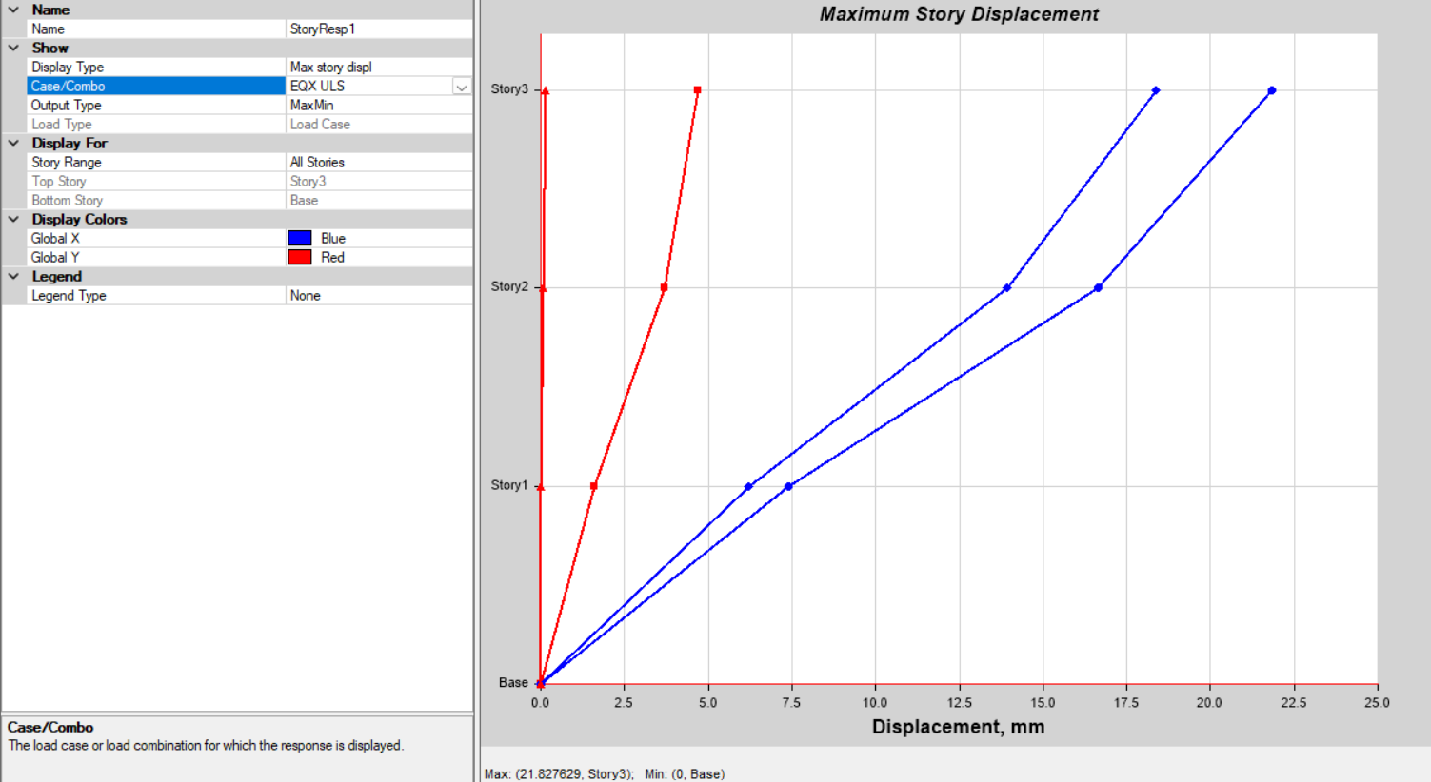

StoreyDisplacement:ULSx

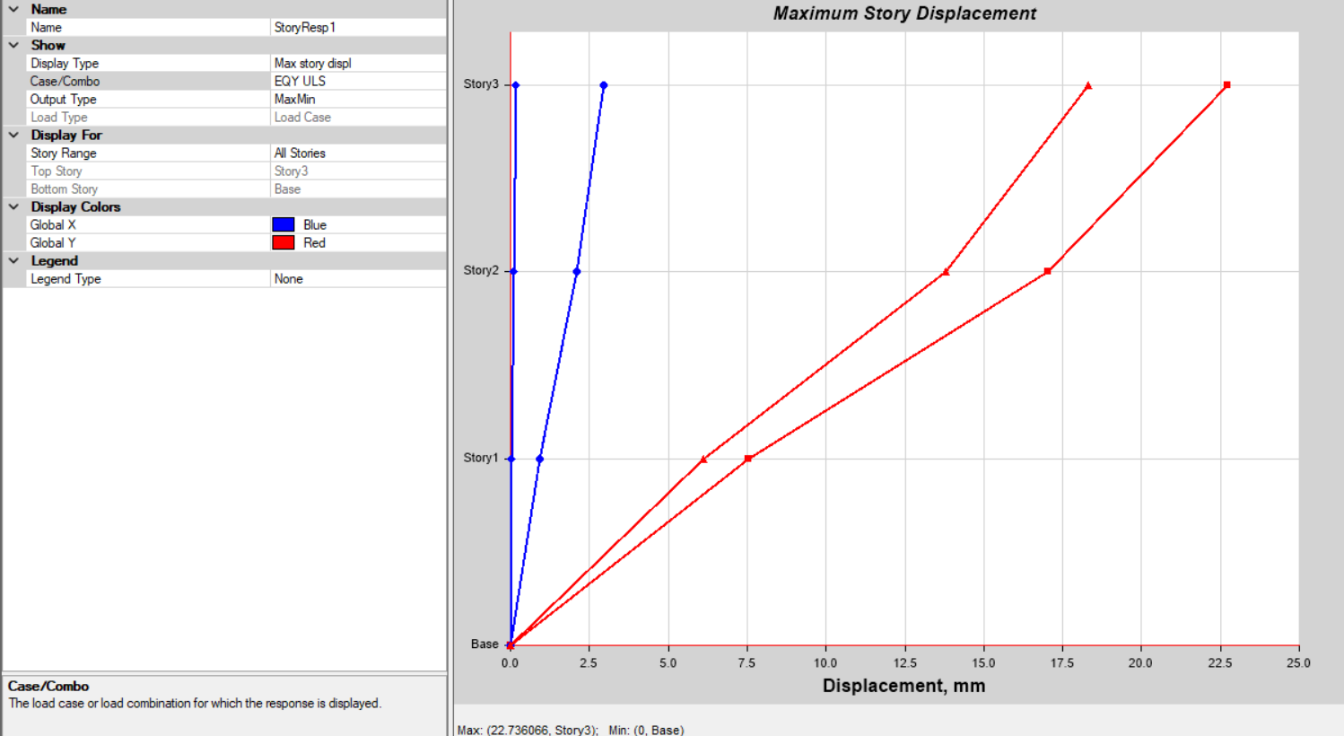

StoreyDisplacement:ULSy

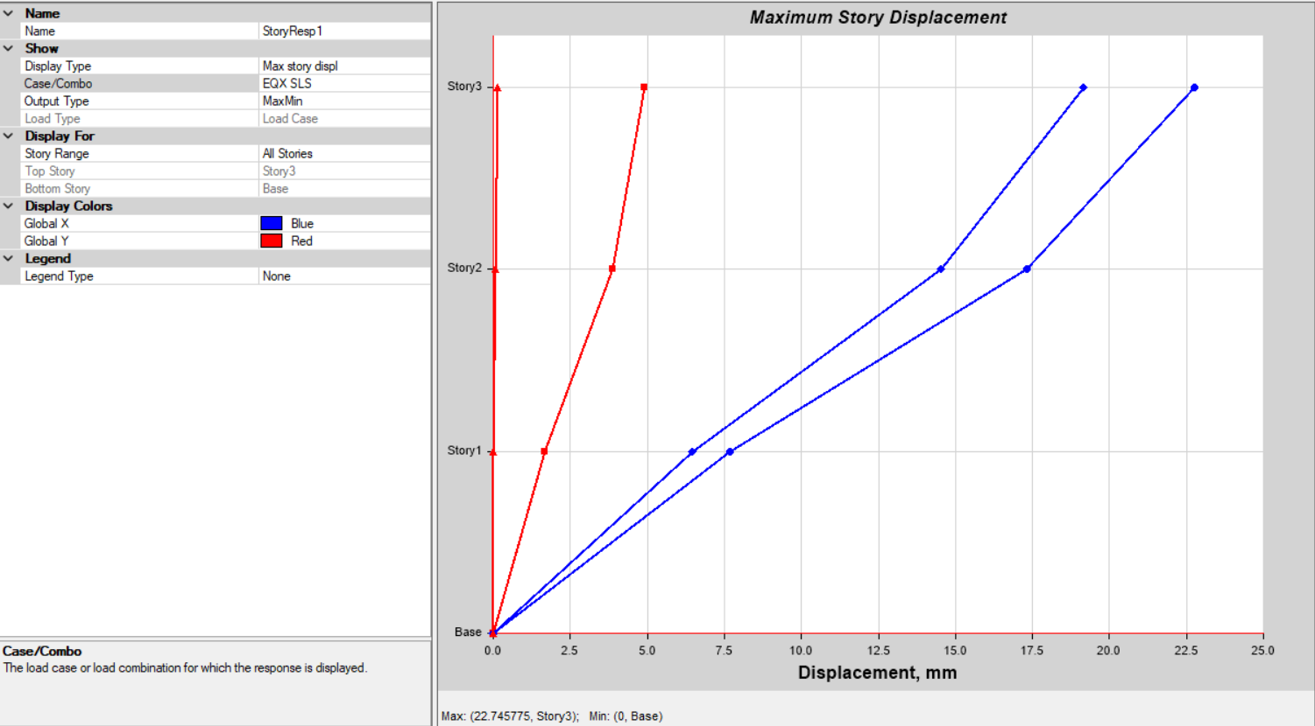

StoreyDisplacement:SLSx

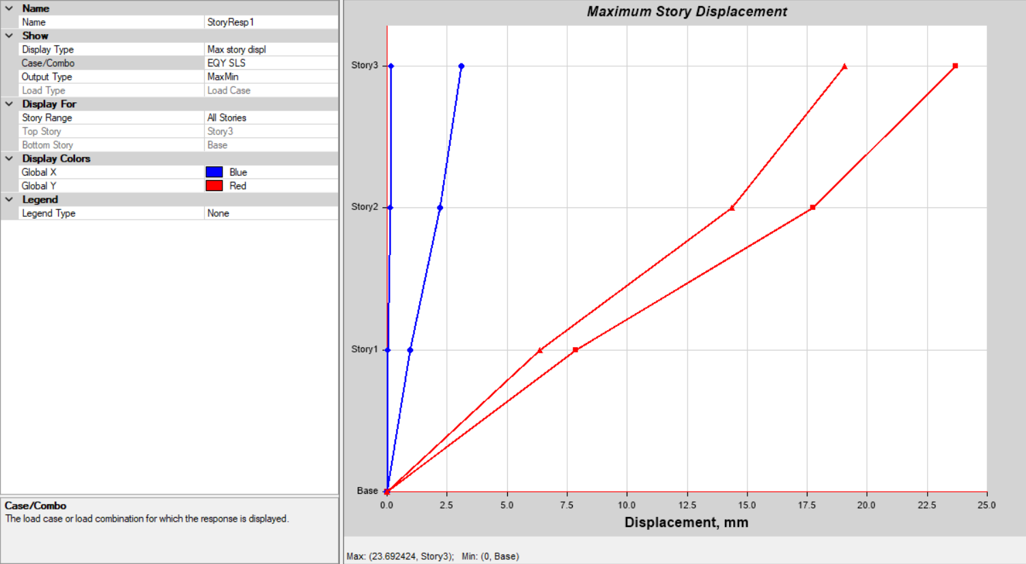

StoreyDisplacement:SLSy

**TORSIONAL IRREGULARITY CHECK**

|  |  |  |  |
| --- | --- | --- | --- |
| ULSEQX |  |  |  |
| Displacement at upper end(A) | = | 21.439 |  |
| Displacement at upper end(B) | = | 18.583 |  |
| A/B | = | 1.15369 | <1.5(OK) |
|  |  |  |  |
| SLSEQX |  |  |  |
| Displacement at upper end(A) | = | 22.341 |  |
| Displacement at upper end(B) | = | 19.365 |  |
| A/B | = | 1.15368 | <1.5(OK) |
|  |  |  |  |
| ULSEQY |  |  |  |
| Displacement at upper end(A) | = | 22.346 |  |
| Displacement at upper end(B) | = | 21.383 |  |
| A/B | = | 1.04504 | <1.5(OK) |
|  |  |  |  |
| SLSEQY |  |  |  |
| Displacement at upper end(A) | = | 23.286 |  |
| Displacement at upper end(B) | = | 22.282 |  |
| A/B | = | 1.04506 | <1.5(OK) |
|  |  |  |  |
| The structure pass in torsion |  |  |  |

## DESIGNINPUTINMUNICIPALITYFORMAT

1. Geometrical Configuration of Structure:
   1. No. of Blocks :-1
   2. No. of Storey :-3
   3. Total Height of the Structure :-9.144m
2. Structural Analysis and Design:
   1. Structural Analysis Software:- ETABS2020
   2. Structural System: - RC buildings with Special Moment Resisting Frame SMRF.
   3. Foundation System:-Isolated and Strap Footing
   4. Loading Parameters:
      1. Dead Load:- As per IS875:1987 Part I
      2. Live Load:- As per IS875:1987 Part II
      3. Seismic Load (As per NBC 105:2020):-
         * Horizontal Base Shear Coefficient

Ultimate Limit State=0.1313

Serviceability Limit State= 0.126

* + - * Seismic Weight:-2642.02kN
      * Base Shear

Ultimate Limit State=346.9kN

Serviceability Limit State= 332.9kN

* 1. Maximum Deflection of theBuilding:-

|  |  |  |
| --- | --- | --- |
| **MaximumDeflection(mm)** | **Allowable(mm)** | **Check** |
| 22.74  23.69 | 57.15(ultimate)  54.864(serviceability) | OK |

* 1. Maximum Drift in theBuilding:-

|  |  |  |
| --- | --- | --- |
| **Maximum Drift** | **Drift should be less** | **Check** |
| 0.012  0.003172 | 0.025(ultimate)  0.006(serviceability) | OK |

* 1. Load Combination Considered:-NBC 105:2020
  2. Concrete Design code Referred:- IS456:2000
  3. Ductile Detailing codeReferred:-

IS13920:2016

* 1. Concrete Grade Used: Beam –M20

Slab – M20

Column – M20

Foundation – M20

* 1. Reinforcement Grade Used: -Fe500